Immersive 180Hz UV   
Visual Stimulus Platform

Jay Borseth 2013.12.04

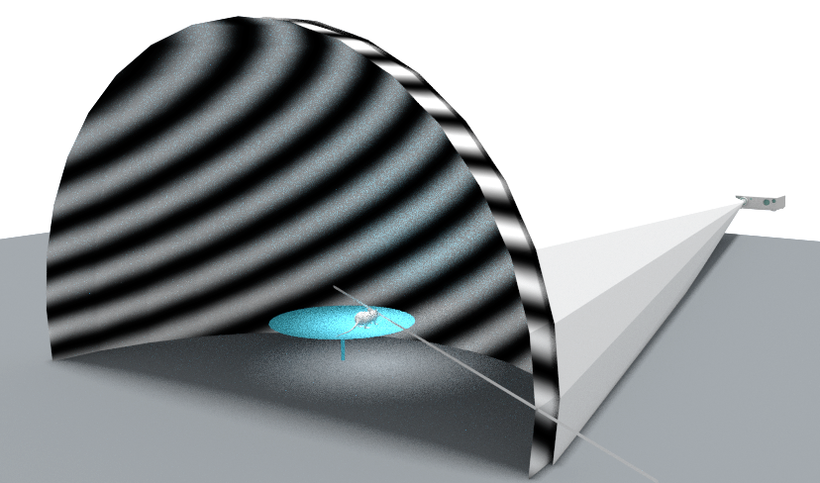

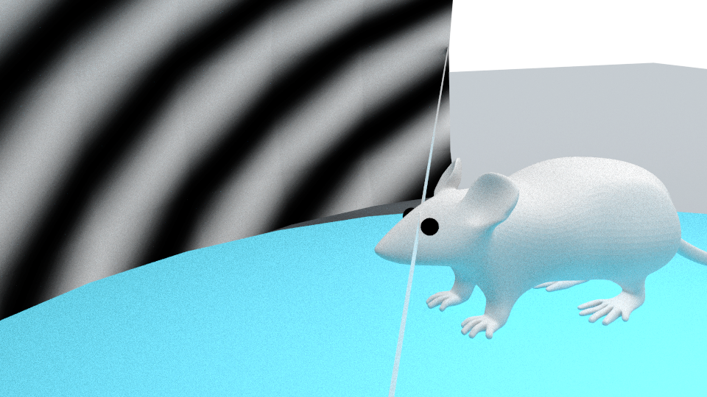

# Dome Designs

## 24” diameter, no mirrors

* Eye to dome: 11.2 cm
* 240 degree stimulation
* Dome to lens: 39.8” assuming LightCrafter 4500

## 24” diameter, single mirror

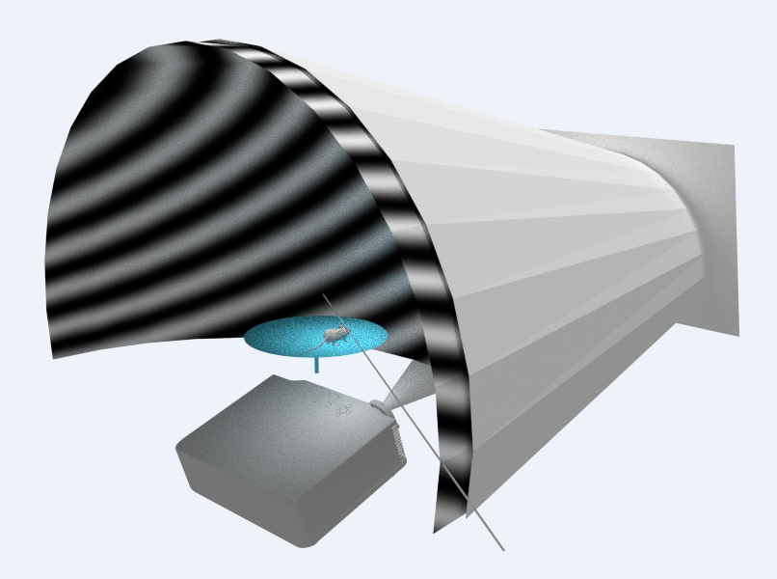

## 24” diameter, single mirror

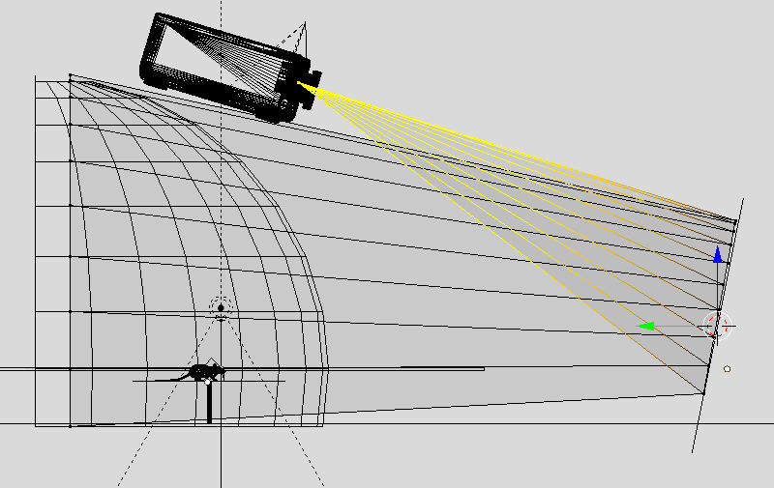

Folded light path, projector above: 29” deep (green) x ~18”high (blue) x 24” wide

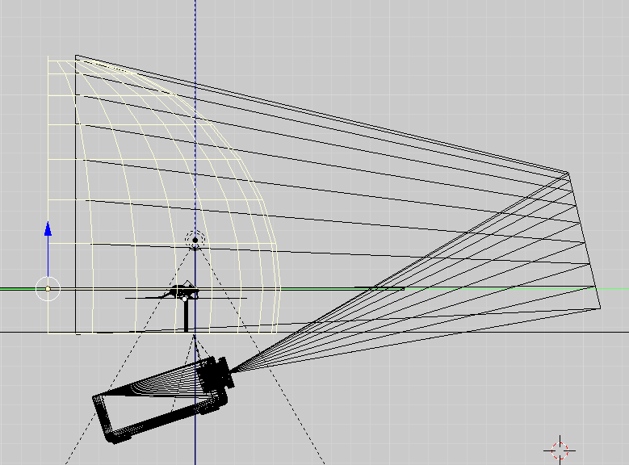

Folded light path, projector below: 29” deep (green) x 24”high (blue) x 24” wide

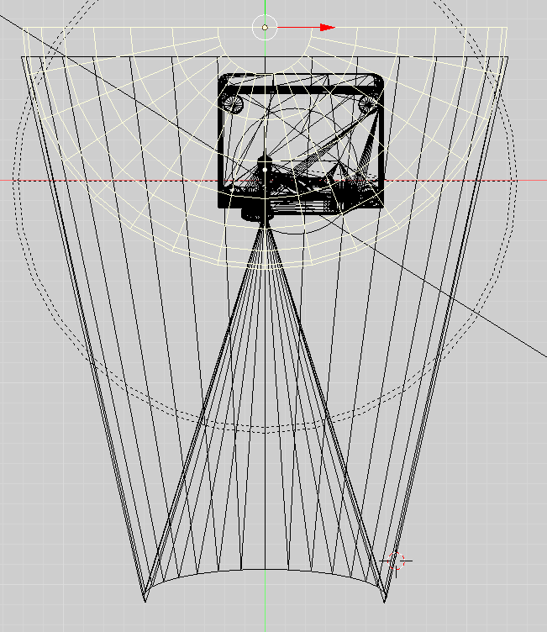

## 12” diameter, multiple mirrors

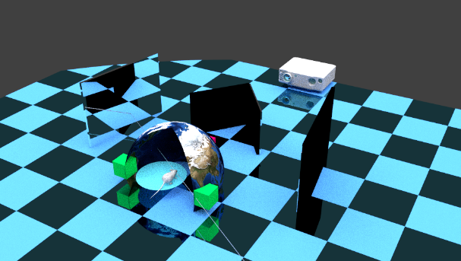

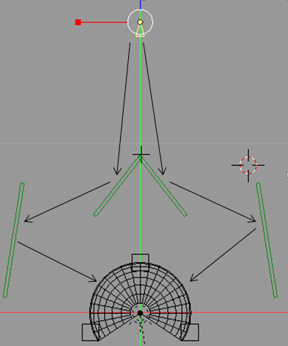

Projector at the top, mirrors are green  
32” wide, 32” deep, 10” high

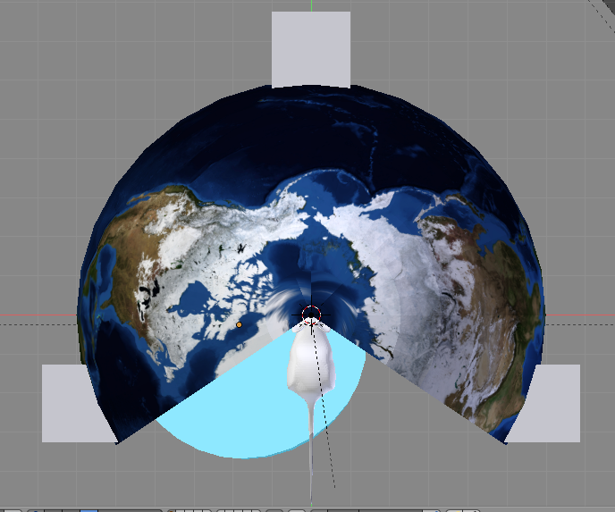

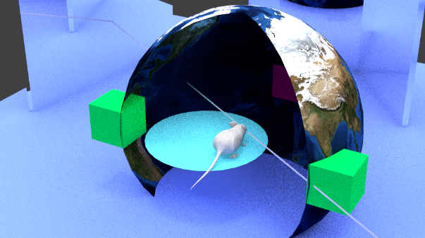

Eye to dome is 6” = 15.24 cm

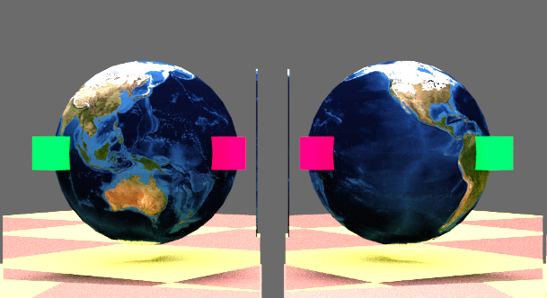

View from projector

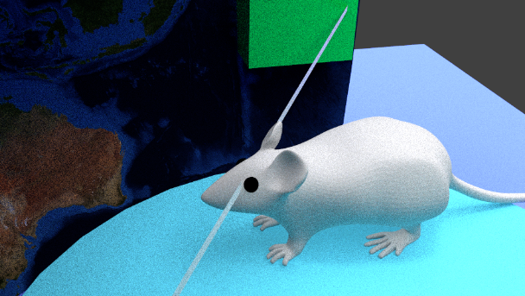

Floor is 4” below eye

### Projection Issues

Will the image be in focus over the entire surface since the light path lengths differ?

### Dome size, distance dome to projector for 1.66 throw angle (33.53 degrees beam angle)

|  |  |
| --- | --- |
| Dome Size | Projector to Dome |
| 12” | 19.96” |
| 18” | 29.88” |
| 24” | 39.84” |

# System Characteristics

## Two eye stimulus

* 240 degree visual stimulus
* 270 degree visual stimulus

## Spatial resolution

* 6 pixels per degree at equator of dome   
  0.95” DLP. 1080x1080 @180 degrees
* 5 pixels per degree at equator of dome   
  0.7”, 0.55”, 0.45” DLP. LCr4500 912x912 @180 degrees
* 3.3 pixels per degree at equator of dome   
  0.3” DLP. LCr3000 608x684 @180 degree

## Bits per pixel

* 8 bits (implies higher end DLP chips, 0.7” and above)
* 7 bits (lower end DLP chips)

## Mouse platform

* Air bearing sphere
* Wheel

# Mouse Eye Characteristics

## Light sensitivity

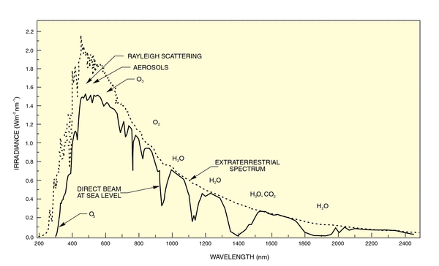

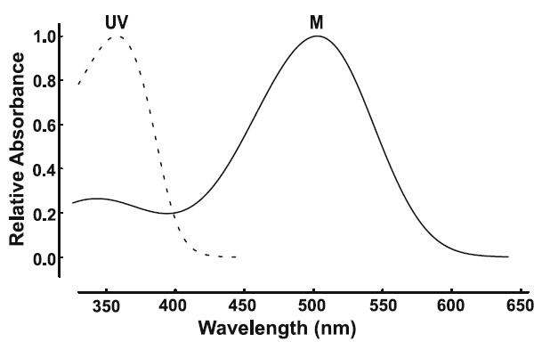 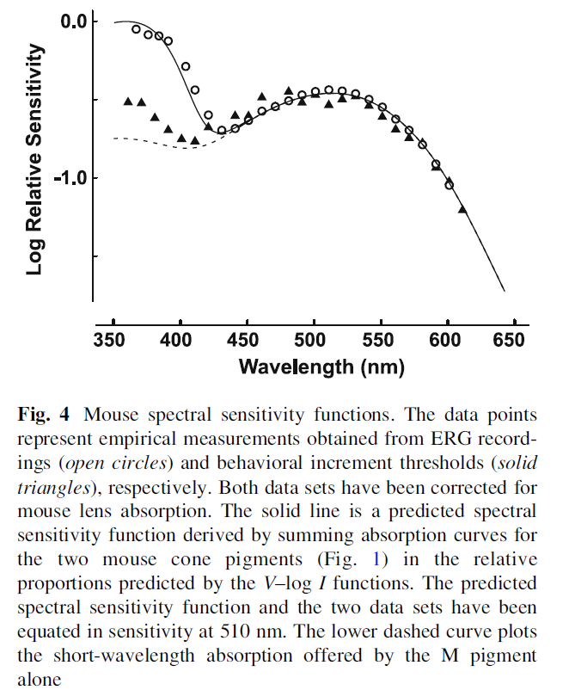

## Spatial resolution

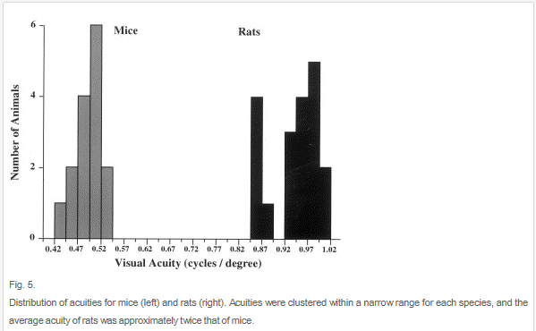

<http://www.sciencedirect.com/science/article/pii/S004269890000081X> (July 2000)

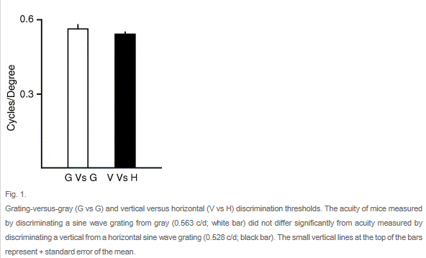

<http://www.sciencedirect.com/science/article/pii/S0042698904004390> (Dec 2004)

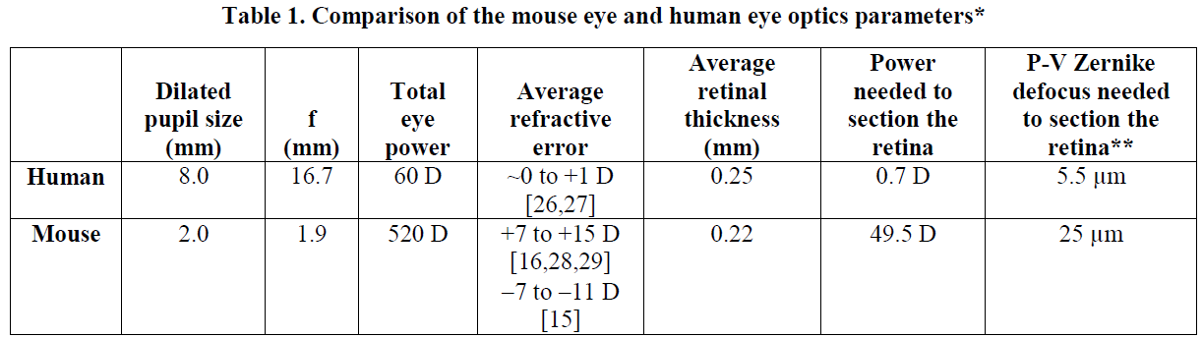

<http://aria.cvs.rochester.edu/papers/Geng-etal_BOE2012.pdf>

# Stimulus

## Visual Channels

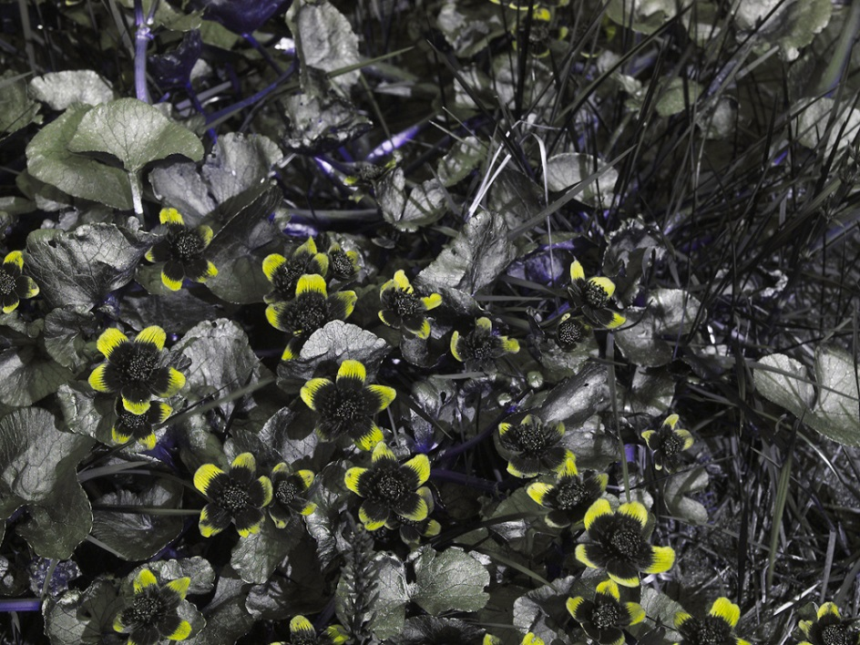

*C. palustris*  Panasonic GH-2, Coastal Optics 60 mm f/4 APO lens, daylight.

* One channel (UV & green together)
* Two channels (UV & green separate)
* Three channels (UV, blue, green)
* If only one channel, what is the relative proportion of UV/Green?
* If color source imagery is used, what is the mapping to monochrome?  
  Y = 0.2126 R + 0.7152 G + 0.0722 B (NTSC)
* Are other combinations acceptable, G/G/UV

## Framerate

Need an exact definition of how RGB channels in one 60Hz frame are to be mapped to either monochrome or multichannel sub-frames.

* 60 Hz
* 120 Hz
* 180 Hz

## Movie Playback

* 60 Hz
* 120 Hz
* 180 Hz

What formats?

## Patterns and Stimulus

* Grayscale Gradients
* Color Gradients / Objects
* Object scaling size to simulate depth
* Object occlusion
* Maximum number of objects displayed simultaneously
* 3D

## Light source

* Broad spectrum stimulus (Xenon lamp)

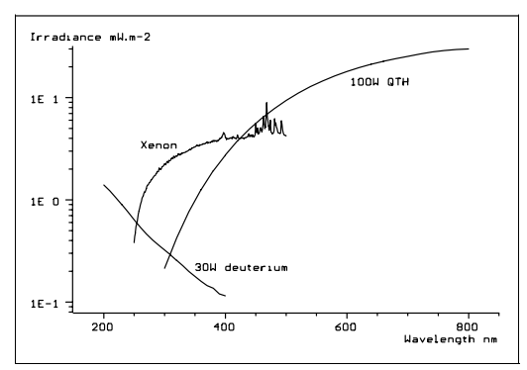

* HBO 100 Mercury Arc Lamp

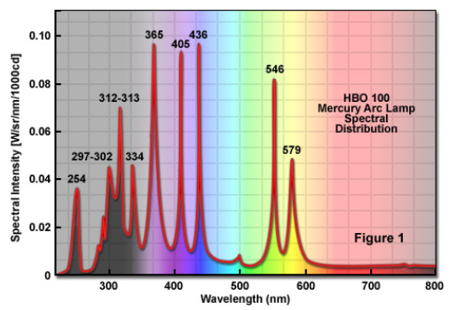

* Narrow spectrum (LEDs)

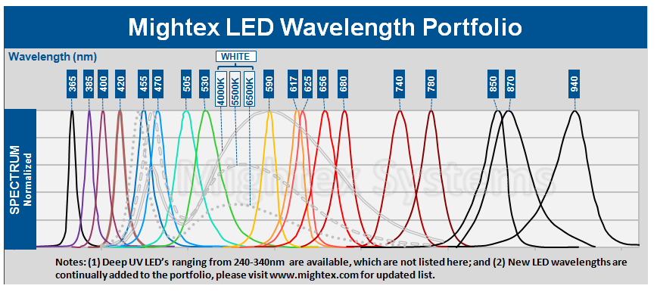

* Brightness range: maximum brightness of 20 mCd/m2

However, at ground level total sunlight power decreases to about 1000–1100 W/m2, and by energy fractions, is composed of 44% visible light, 3% ultraviolet (with the Sun at its zenith), and the remainder infrared.[[8]](http://en.wikipedia.org/wiki/Ultra_violet#cite_note-8)Thus, sunlight's composition at the zenith at ground level, per square meter, is about 527 W infrared radiation, 445 W [visible light](http://en.wikipedia.org/wiki/Visible_light), and 32 W UV.[[9]](http://en.wikipedia.org/wiki/Ultra_violet#cite_note-9)

Ordinary window glass passes about 90% of the light above 350 nm, but blocks over 90% of the light below 300 nm.[[12]](http://en.wikipedia.org/wiki/Ultra_violet#cite_note-12)[[13]](http://en.wikipedia.org/wiki/Ultra_violet#cite_note-13)[[14]](http://en.wikipedia.org/wiki/Ultra_violet#cite_note-14)

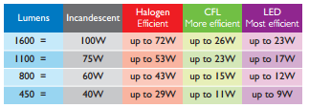

# Materials

## Typical Dome plastics

MC is the most common Plexiglas.

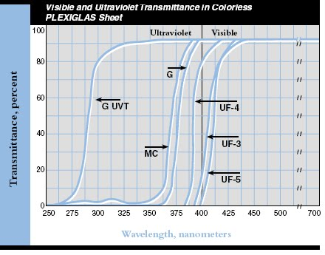

<http://www.cleardome.com/domes.htm> uses a comparable plastic called Acrylite FF which looks like:

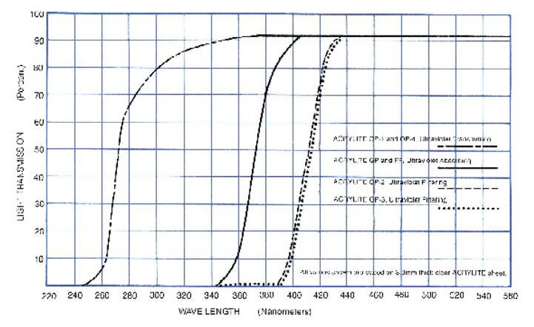

Solid line upwards at 340nm is Acrylite FF

## Glass transmission in UV

<http://www.quora.com/Ultraviolet-Radiation/Does-an-ultraviolet-ray-change-direction-through-a-mirror> 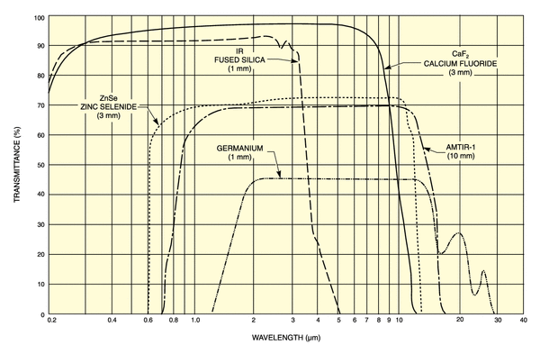

Most prevalent type:

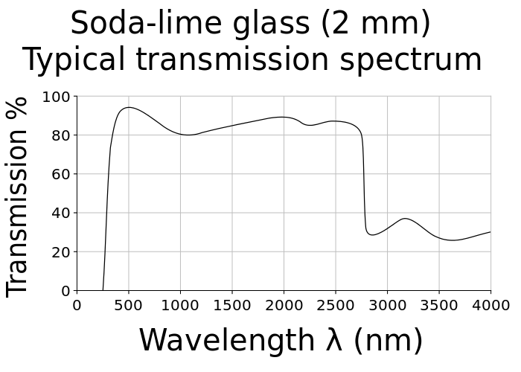

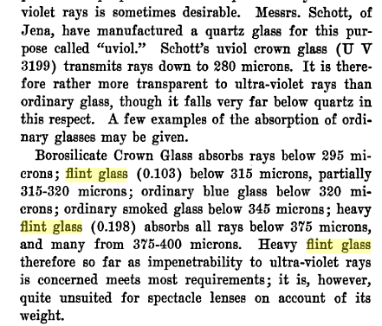

<http://books.google.com/books?id=XAM2AQAAMAAJ&pg=PA432&img=1&zoom=3&hl=en&sig=ACfU3U3rwZBHh6O3AOOKEQgT3J1Hz_QNmw&ci=210%2C492%2C609%2C473&edge=0>

## Metal reflectance in UV

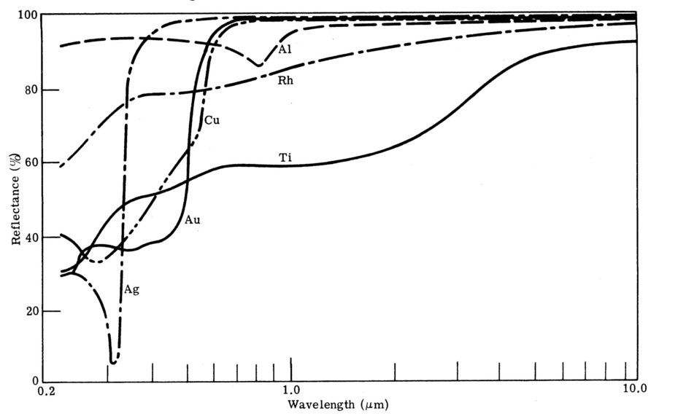

Polished aluminum mirrors should work fine.

# UV LED Sources

## Lumex 355, 365, 377, 385, 405 nm

<http://www.lumex.com/en/products>

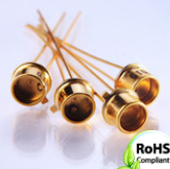



## LED Engin, 365 nm

<http://www.mouser.com/ds/2/228/LZ1-00UV00-257812.pdf>

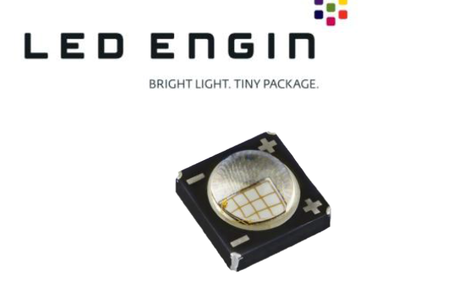

▪ 365nm UV LED with industry highest flux performance

▪ Up to 1000mW flux output at 2.8W power dissipation

▪ Ultra-small foot print – 4.4mm x 4.4mm

## Seoul VioSys, 365, 375, 385, 395 nm

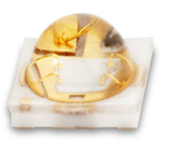

<http://www.socled.com/en/product/categorys.asp?catecode=1002003>

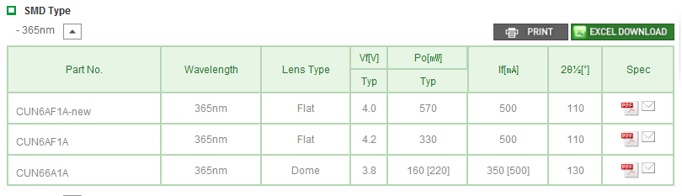

## Philips Luxeon

<http://www.philipslumileds.com/products/luxeon-uv>

* 2.2mm2 micro footprint
* 1A max drive current

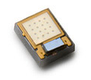

## Luminus

<http://www.luminus.com/products/uv.html>

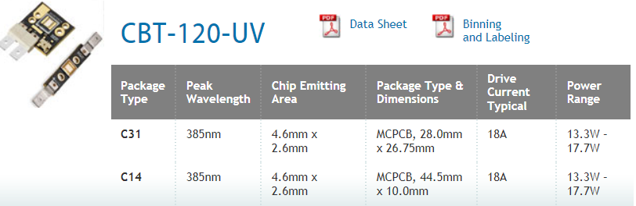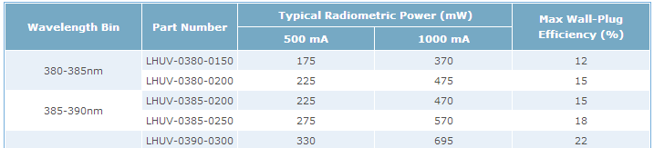

### Reference Material

LEDs for Pico Projectors<http://www.sidchapters.org/ba/Archives/2012/SID%20BA%20LED%20for%20Pico%20Projectors_final.pdf>

# DLP Chips

## Chipsets, resolutions, and Maximum Pattern Rates

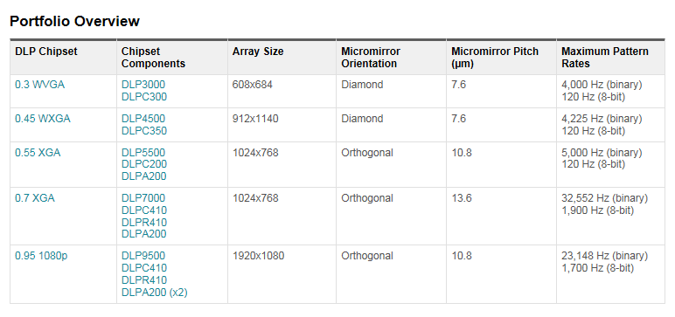

### DLP Prices

For just the micro-mirror chip itself

|  |  |
| --- | --- |
| DLP size | Qty. 1 price |
| 0.3” | $140 |
| 0.45” | $200 |
| 0.55” | $600 |
| 0.7” | $1100 |
| 0.95” | $4100 |

### DLP mirror geometry

Devices smaller 0.45” and smaller use a diamond geometry resulting in jagged vertical and horizontal lines. Larger devices use a rectangular mirror grid.

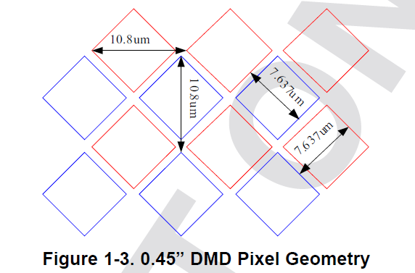

### DLP and UV

Problems with UV and DLP devices

* In many non-UV designed system there is a plastic lens called the “fly eye” in the light path which will yellow after just a day of high UV exposure.
* Optics typically have coatings which do not pass UV.
* Gas used between the cover and DLP mirrors acts as a lubricant for DLP mirrors and “thickens” with UV exposure. When it gets thick, the mirrors stop moving.

### HDMI / DVI connector bandwidths

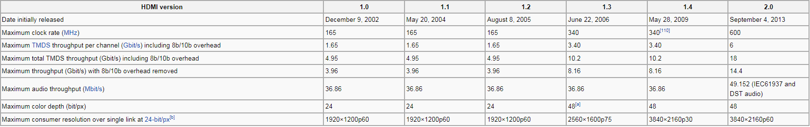

Single link pixel clock: 340MHz - (1,920 × 1,080) @ 60 Hz with CVT-RB blanking (139 MHz)

Dual link pixel clock: 680MHz - (1,920 × 1,200) @ 120 Hz with CVT-RB blanking (2 x 154 MHz)

## DLP window transmission

<http://www.ti.com/lit/an/dlpa031b/dlpa031b.pdf>

### DLP 0.17”, 0.33”, 0.55” (0.45 is unknown)

Corning Eagle XG <http://www.delta-technologies.com/downloads/Eagle%20XG.pdf>

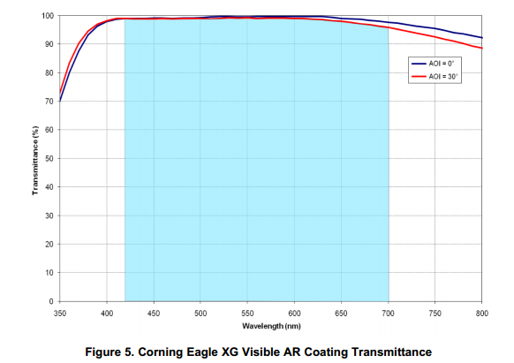

### TYPE-A: 0.7”, 0.95”

Corning 7056

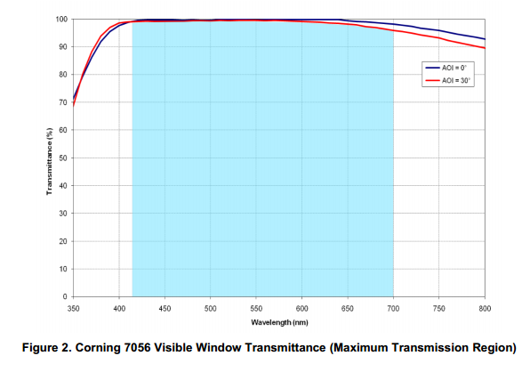

# DLP Hardware Options

## LC3000-PRO DLP Pico Projector with UV LED DLP Pico

<http://keynotephotonics.3dcartstores.com/LC3000-PRO-DLP-Pico-Projector-with-UV-LED-DLP-Pico-Projector_p_48.html>

$1450

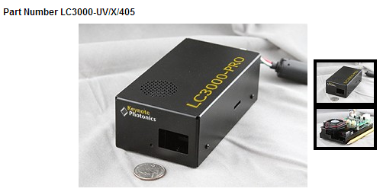

* 0.3” DLP
* 385, 400, 405 nm LED options. Replaces Blue LED with UV LED.
* 100 lumens (PRO with white LED), 50 lumens standard, UV not quoted
* ProjectorThrow ratio = 1.66
* Focus range 364mm to 2169mm (85.39 inches)
* width = distance / throw ratio
* 12” dome, dome to lens is 19”
* 18” dome, dome to lens is 29.88”
* 24” dome, dome to lens is 39.84”

### Issues

* 120 Hz @ 8-bits, 180 Hz @ 7-bits
* No spec given for UV output power
* Can the LC3000 drive multiple LEDs simultaneously?

Yes, this is how we can create the higher brightness for white-light structured light measurement.

This is case, we would have in every video frame: UVa + Ga , UVb + Gb, UVc + Gc ; next frame ...

The green LED used in the light engine uses a phosphor recapture technique, so the actual spectrum is fairly broad and will easily cover 511 nm.

The 3rd LED needs to be in longer than yellow wavelengths that are consistent with the dichroic filters used.

## LightCrafter 4500

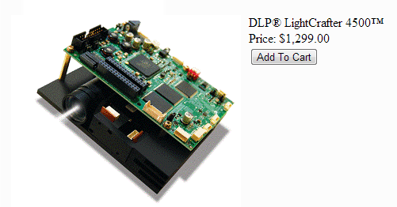

* 0.45” DLP (912 x 1140)
* Brightness 150 lumen
* Throw ratio = 1.66
* Focus range 300mm to infinity
* width = distance / throw ratio
* 12” dome, dome to lens is 19”
* 18” dome, dome to lens is 29.88”
* 24” dome, dome to lens is 39.84”

### Issues

* Can’t substitute light modules.
* No way to supply broadband light at 180Hz.
* 120 Hz @ 8-bits, 180 Hz @ 7-bits
* Not rated for UV. “Fisheye” lens will yellow with UV exposure.

## LightCrafter Pro4500 for UV

<http://www.wintechdigital.com/product_s.asp?id=17>

$1975 (< $800 in high volumes)

* Same as regular LCr4500 with UV upgrades
* WinTechDigitial is manufacturer of LCr sold by TI
* New product, available end of Jan 2013 (30 units total manufactured)
* Pro model handles UV includes glass replacement for “flyeye” lens and different coating for the 20 other lenses in the light module.

### Issues

* No way to supply broadband light at 180Hz.
* 89.6 mm working distance lens! (designed for near field UV curing)
* Not yet available

### Contacts

* David Smith (Sales Mgr, Texas) 804 363-4266
* Charlie (David’s boss, Anaheim) 1-949-450-1014

## CEL5500-UV and CEL5500-Fiber

<https://www.dlinnovations.com/wp/?page_id=759>

~$6500

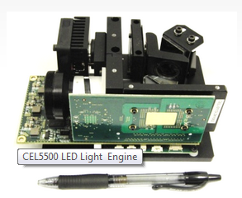 [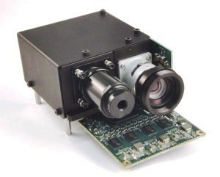](https://www.dlinnovations.com/wp/wp-content/uploads/2013/12/DLi-CEL5500-Fiber-Light-Engine_Feature.jpg)

* .55” DLP (1024x768)
* UV specific model available.
* CEL model and Fiber model have identical output optics.
* 7mm Fiber Light-Guide available
* 37mm projection lens ring
* 1.8 throw ratio
* Red, green, blue, and white LEDs are available, with a typical output of 225 lm in the standard white package. The red LED has the brightest illumination of all the modules with a maximum of 245 lumens. The green has an LED output of 230 lumens and the blue LED provides up to 55 lumens. <https://www.dlinnovations.com/wp/?page_id=2048>

### Issues

* “Running the CEL5500-UV at 365nm will not work because the glass is opaque at 365nm.  We have ran and tested the CEL5500 at 385nm and we consistently get 50% transmission” – Justin Lemon
* UV LED version has only a single UV LED. No way to output green and UV simultaneously.
* Use Light Guide to supply broadband light source to all channels.

### Light Modules

Light Modules from Vialux for use with CEL5500

<http://www.vialux.de/HTML/optik_lichtq.htm#oben>

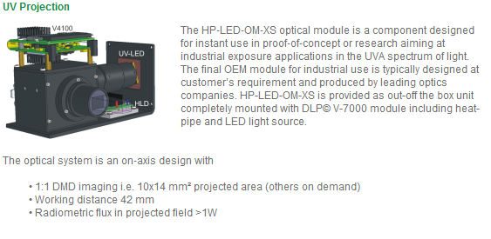

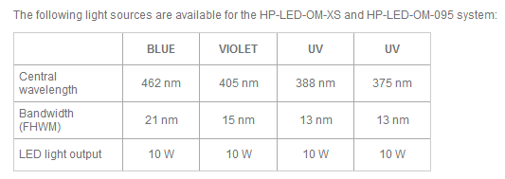

## X3 Machine Vision Solution with DLP 5500 (X3-PM55)

<http://keynotephotonics.3dcartstores.com/X3-Machine-Vision-Solution-with-DLP-5500-X3-PM55_p_14.html>

$3999

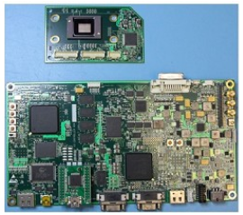

* .55” DLP (1024x769)
* No optics
* Can be converted to HDMI 8bit@180Hz monochrome for ~40K firmware development

### Issues

* Single link HDMI

### DepthQ 360 DLP Projector

<http://www.crsltd.com/tools-for-vision-science/displays/depthq-360-dlp-projector/nest/depthq-360-faq>  
Buy direct from: <http://www.depthq.com/specifications.html>  
Based on: <http://www.infocus.com/projectors/office-projectors/infocus-in2110-projector-series/infocus-in2116-projector>

$4995

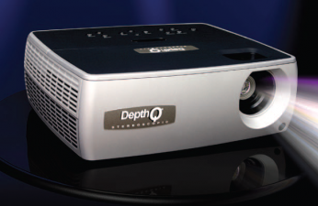

* 0.55” DLP (1024x768)
* 360 Hz native projection using 120Hz from display controller. Will not run at 60Hz input.
* Developed in partnership with Howard Hughes Medical Center / LightSpeed / InFocus / TI
* Based on InFocus 2116, they just flash the FPGA and remove the color wheel.
* 2400/ 3600 Lumens
* Min image size 26”
* Min projection distance 3.94’

### HHMI

* Anthony Leonardo at HHMI Janelia Farm Research Campus ([leonardoa@janelia.hhmi.org](mailto:leonardoa@janelia.hhmi.org)) was the researcher responsible for getting LightSpeed, TI, and InFocus to jointly develop the DepthQ 360 DLP Projector in 2007 / 2008.
* HHMI paid $150K for customization of commercial InFocus IN2116 projector.
* HHMI purchased 40 of 50 units and probably 100 total were sold.
* InFocus IN2116 is out of production. Remaining stock is unknown.
* Cambridge Research Systems is just a reseller.
* Customization consists of removal of color wheel and reprogramming FPGA to not do 2x color wheel RGBW conversion but just present RGB as separate temporal grayscale images.
* TI performed FPGA programming. They retain the rights to this code, and apparently neither HHMI nor LightSpeed have the source.
* Each lab at HHMI further modifies the DepthQ 360 for optics customization, laser light guide in some cases, stereoscope micro-lens.
* Some labs are using Blender Game Engine for stim creation.
* They have custom rendering package called StimGL written in C++/OpenGL which performs grayscale to RGB24 packing. Uses unmodified graphics drivers. Sounds similar in capabilities to PsychoPy. Anthony said he would forward the source code.

.

### References

DragonFly <http://zoology.ou.edu/pdf_documents/Neuromunch/Gonzalez-Bellido_et_al_2013.pdf>

### Contacts

Dan Lawrence 206 290-0251 [dan@lightspeed.com](mailto:dan@lightspeed.com)

[dan.lawrence@lightspeeddesign.com](mailto:dan.lawrence@lightspeeddesign.com)>

Leonardo, Anthony [leonardoa@janelia.hhmi.org](mailto:leonardoa@janelia.hhmi.org) led design project at HMMI

## DLi3000 Digital Light Innovations

<https://www.dlinnovations.com/wp/?page_id=750>

$

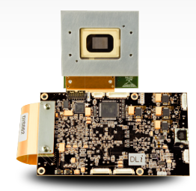 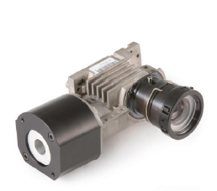

* 0.7” (1024x768) or 0.95” (1920X1080) DLP
* No optics included, but light fiber and LED options available
* Integrated DVI connector

### Issues

* Single link HDMI via D2D DVI Interface Expansion card (Silicon Image Sil1161 DVI receiver max is 165 Mhz)
* Doesn’t come with any control software or API (not compatible with Light Commander).

## DLi4110 Digital Light Innovations

<https://www.dlinnovations.com/wp/?page_id=932>

$

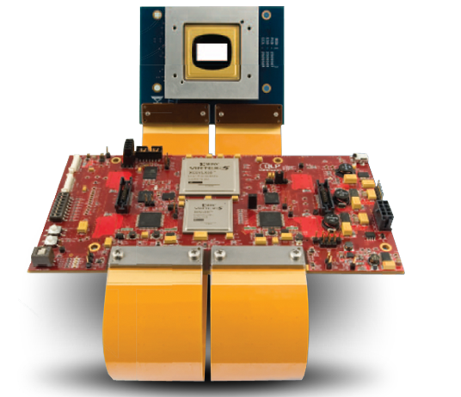 

* 0.7” (1024x768) or 0.95” (1920X1080) DLP
* No optics included, but light fiber and LED options available

### Issues

* Single link HDMI via D2D DVI Interface Expansion card (Silicon Image Sil1161 DVI receiver max is 165 Mhz)

## VPixx ProPixx

<http://www.vpixx.com/products/visual-stimulus-displays/propixx-lite.html>

$31K

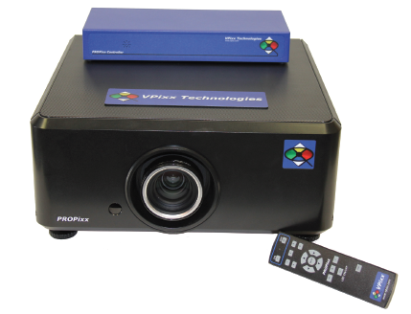

* 0.95” DMD, (1920 x 1080)
* 180 Hz native projection (3 channels!)
* Brightness: 600 lumens
* Run any software application without modification at 180Hz

### Issues

* $31K

# UV and LCD Displays

References:

Don’t Try This

I used standard 365nm fluorescent tubes, though I doubt standard twisted nematic nematic displays will be able to polarise UV of any wavelength.

The only polarisers I could find which work in the UV spectrum are tiny and very expensive. I don't know what range of wavelength the twisted nematic themselves can rotate polarization in, but the Polaroid type filters used in displays certainly don't work at 365nm.

<http://hexifact.co.uk/?tag=uv-lcd-photoresist-polariser-pcb>

# LCOS Liquid Crystal on Silicon

References:

<http://electroiq.com/blog/2001/05/packaging-of-liquid-crystal-on-silicon-microdisplays/>

Photostability of liquid crystals and alignment layers (365 nm)

<http://lcd.creol.ucf.edu/publications/2005/JSID%20Wen%20UV.pdf>

## Himax

<http://www.himaxdisplay.com/en/product/info.asp>

Used in Google Glass.

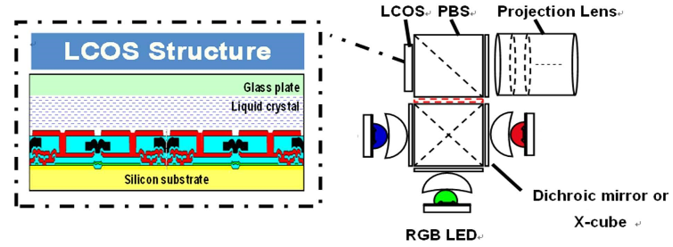

## Syndiant

<http://www.syndiant.com/pdfs/SYL2271_ProductBrief.pdf>

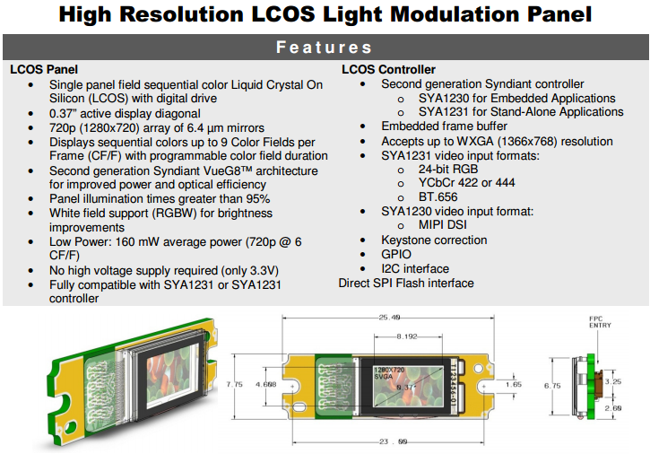

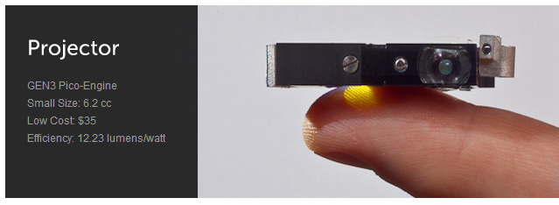

<http://www.imagineoptix.com/projectors/>

## Holoeye

<http://holoeye.com/lcos-microdisplays/hed-7200-color-lcos/>   
<http://holoeye.com/wp-content/uploads/2011/07/LCOS_Microdisplays.pdf>

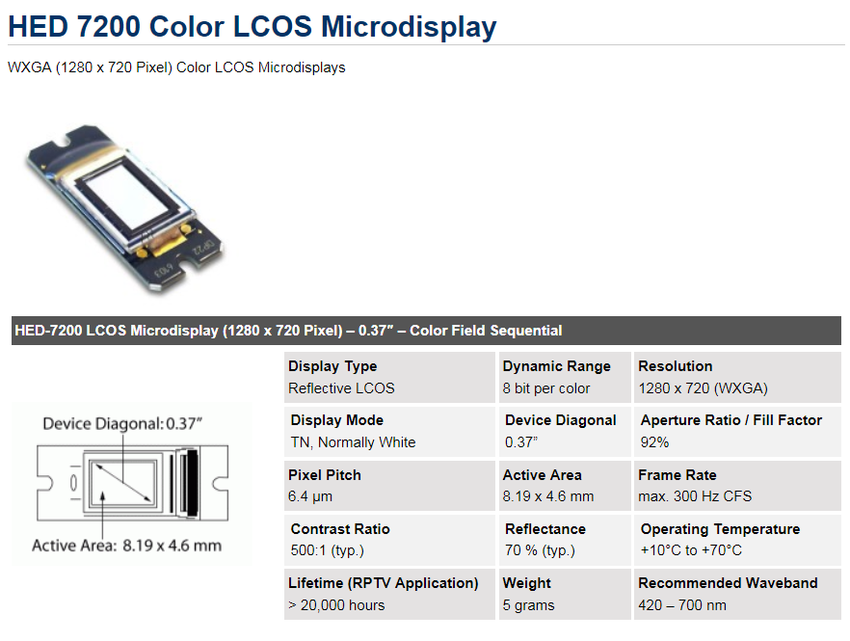

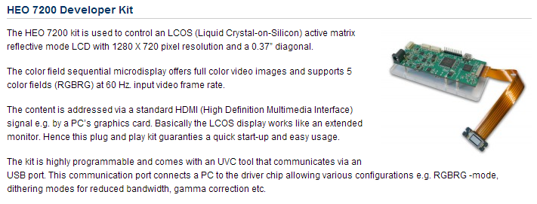

## Jasper Display Corp.

<http://www.jasperdisplay.com/products/detail/253/>

* 1920x1080
* 480Hz Color Field
* 120 Hz Frame Rate
* Color sequential
* 400 lumens

# Spatial Light Modulators

References

Some Applications of Spatial Light Modulators in Optical Imaging and Metrology  
<http://www.wiley-vch.de/books/sample/3527410643_c01.pdf>

## Hammamatsu  LCOS-SLM (Liquid Crystal on Silicon-Spatial Light Modulator)

<http://www.hamamatsu.com/jp/en/product/alpha/P/4015/index.html>

Hamamatsu produces OEM devices that meet your requirements in the wavelength range from 355 nm to 1550 nm. We are able to design and optimize device elements according to light wavelength used in your application.

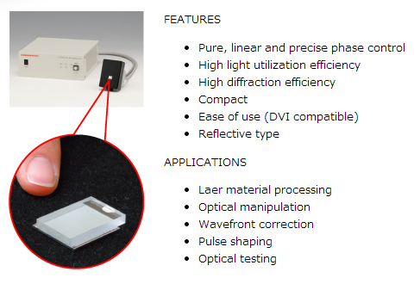

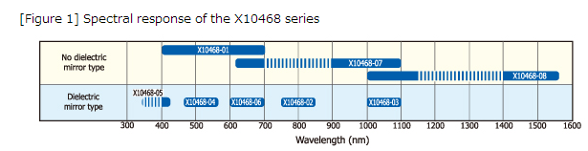

### Issues

* Appears to be 60Hz only.

## Boulder NonLinear Systems Spatial Light Modulators XY Series

<http://www.bnonlinear.com/products/xyslm/XY.htm>

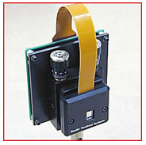

* Wavelengths include:  532 nm, 635 nm, 785 nm, 1064 nm, 1550 nm
* Custom capabilities:  360 nm, 485 – 1650 nm, 1.5 – 2.5 um, 3 – 5 um, 8 – 12 um
* 16-bit 512x512 images can be transferred across the DVI interface at a rate limited by the graphics card used. If a custom graphics card is used the hardware supports up to 200 Hz frame rates. These SLMs are optimized to provide very fast frame rates (up to 1 kHz). However, as with all ferroelectric liquid crystal devices, the duty cycle is limited to a maximum of 50:50 (drive requirements force use of true image for half of cycle and inverse image for other half).

## HoloEye LC-R 720: High Speed Spatial Light Modulator

<http://holoeye.com/wp-content/uploads/Spatial_Light_Modulators.pdf>

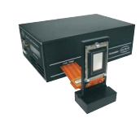 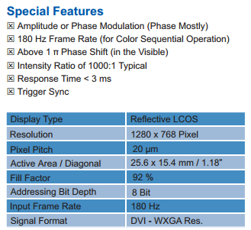

Cambridge Correlators

<http://www.cambridgecorrelators.com/SDE1024%20Spatial%20Light%20Modulator.pdf>

**$1,200USD**

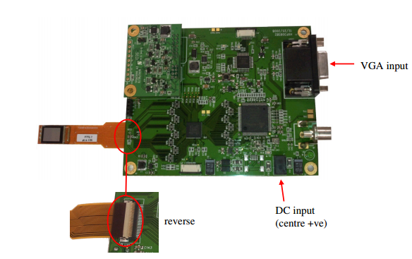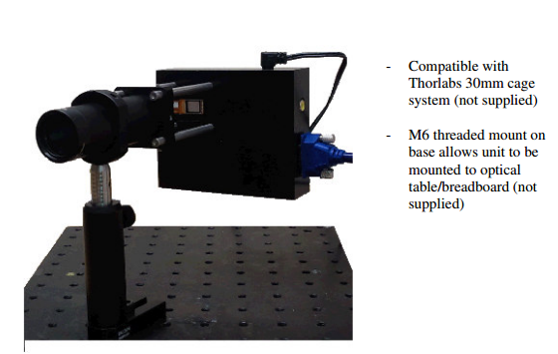

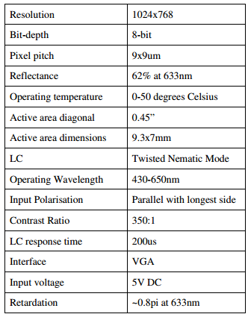

Issues

# HUD & VR Systems

## Google Glass

Uses field sequential LCOS from HiMax. 640x360. Retinal projection. Not full screen.

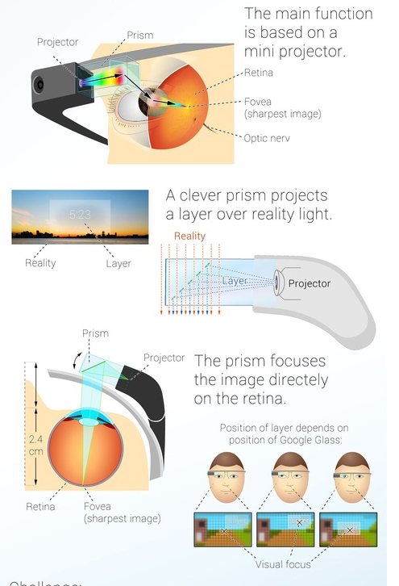

## Lumus

<http://www.lumus-optical.com/index.php?option=com_content&task=view&id=9&Itemid=15>

Full screen display. Available Q1 2014. In lens projection.

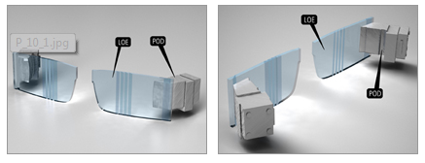

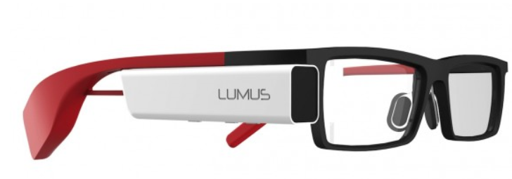

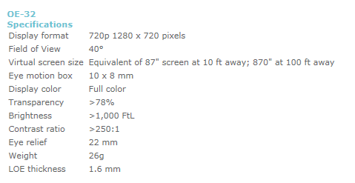

## Luzix Wrap1200DX

<http://www.vuzix.com/consumer/products_wrap_1200dx.html>

$499

Some models are LCOS

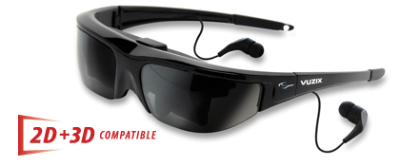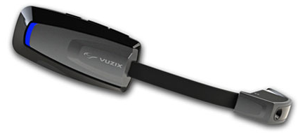

## OmniVision

<http://www.ovt.com/download_document.php?type=document&DID=98>

Full screen display

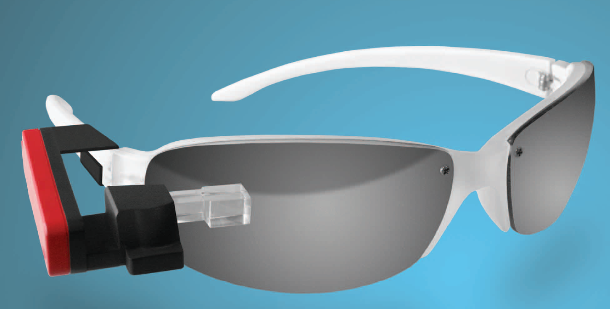

# Software

## Operating System

* Windows
* Mac
* Linux

## Applications

* PsychoPy
* matlab
* visionegg
* other